

## AMERICAN INTERNATIONAL UNIVERSITY–BANGLADESH (AIUB) FACULTY OF ENGINEERING

**DEPARTMENT OF ELECTRICAL AND ELECTRONIC ENGINEERING DIGITAL LOGIC AND CIRCUITS LABORATORY**

## Fall 2023-2024

**Group: 02, Section: Q**

**LAB REPORT ON**

***Design and implementation of multivibrators using Timer IC.***

## Supervised By

**DR. TANBIR IBNE ANOWAR**

## Lecturer, EEE

**American International University-Bangladesh Submitted By:**

|  |  |
| --- | --- |
| **Name** | **ID** |
| MD. FAHIM MURSHED | 22-46695-1 |
| MD. ATIK ISHRAK SUJON | 22-46684-1 |
| S.M. MUJAHID SOUROV | 22-49679-3 |
| TRIDIB SARKAR | 22-46444-1 |
| NUSHRAT JAHAN | 22-46149-1 |

**Date of Submission**:  **8th December, 2023**

# Introduction:

The name of the timer comes from the three 5 kΩ resistors which are embedded in it. This IC gives precise time at the output which is must in the time related circuits. One of its basic operations is to produce clock pulses with predefined frequency as an astable multilibrary. Another operation is to work like a stopwatch which is done in monostable mode. We will see these two operations in this experiment. The following figure is the layout of the 555 Timer IC which allows us to focus on the functions of the circuit.

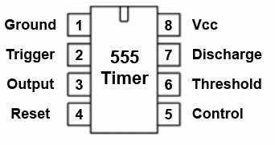

Figure 1:Pin configuration of the 555 timer IC.

# Theory and Methodology:

### Astable Multivibrator:

Astable Multivibrators are free running oscillators which oscillate between two states continually producing two square wave output waveforms. Regenerative switching circuits such as the Astable Multivibrator are the most used type of relaxation oscillator because not only are they simple, reliable, and easy to construct they also produce a constant square wave output waveform. Unlike the Monostable Multivibrator or the Bistable Multivibrator, we looked at in the previous tutorials that require an “external” trigger pulse for their operation, the Astable Multivibrator has automatic built in triggering which switches it continuously between its two unstable states both set and reset.

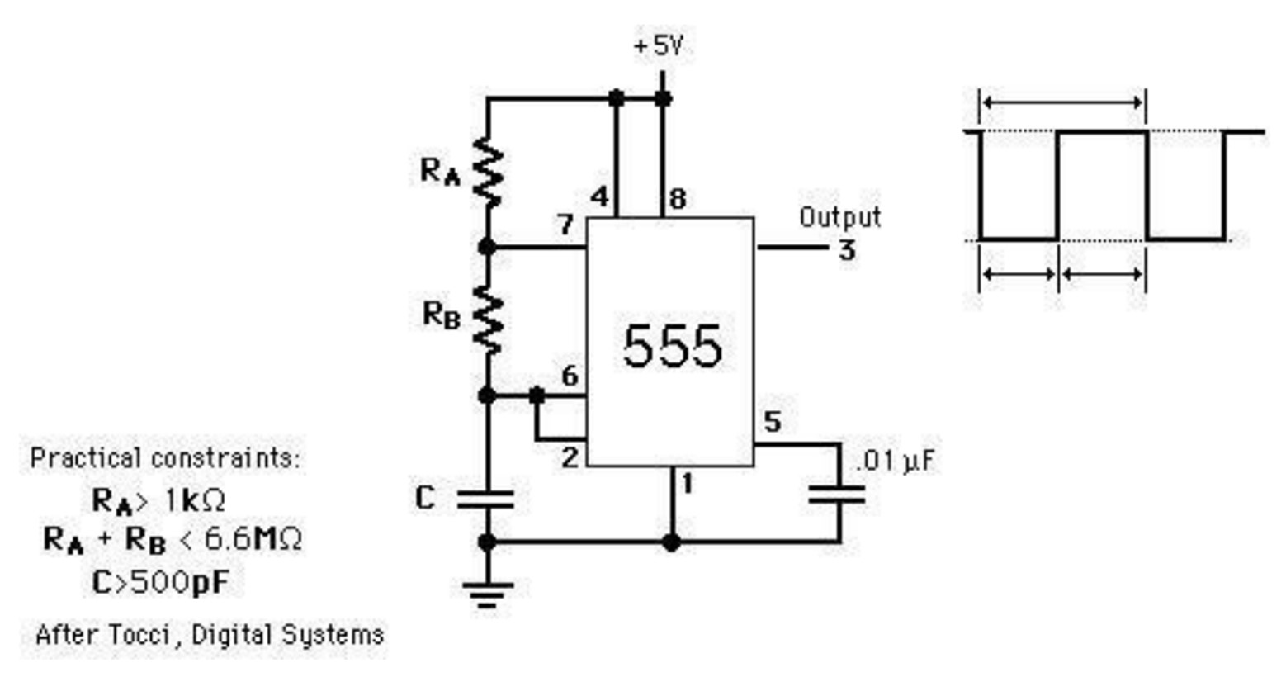

Figure 2:555 timers connected as an astable multivibrator

The time that the output is high, TL is how long it takes C to discharge from 1/3 of Vcc to 2/3 of Vcc. It is expressed as

TH = 0.7(RA + RB) C

The time that the output is low, TH is how long it takes C to charge from 2/3 of Vcc to 1/3 of Vcc. It is expressed as

TL =0.7RBC

The time period, T = TH + TL = 0.7(RA + 2RB) C Frequency of Oscillation, f = 1/T = 1.44 / (RA + 2RB) C Duty cycle, D = TH/ T = (RA + RB)/ (RA + 2RB) x 100%.

### One shot multivibrator:

Multivibrators are Sequential regenerative circuits either synchronous or asynchronous and are used extensively in electronic timing applications. Multivibrators produce an output wave shape resembling that of a symmetrical or asymmetrical square wave and as such are the most used of all the square wave generators. The monostable multivibrator belongs to a family of oscillators commonly called “Relaxation Oscillators “. Discrete multivibrators consist of a two-transistor cross coupled switching circuit designed so that one or more of its outputs are fed back as an input to the other transistor with a resistor and capacitor (RC) network connected across them to produce the feedback tank circuit. Multivibrators have two different electrical states, an output “HIGH” state and an output “LOW” state giving them either a stable or quasi-stable state depending upon the type of multivibrator. One such type of two-state pulse generator configuration is called Monostable Multivibrators.

Pulse width of the output is given by T= 1.1 RC (in seconds)

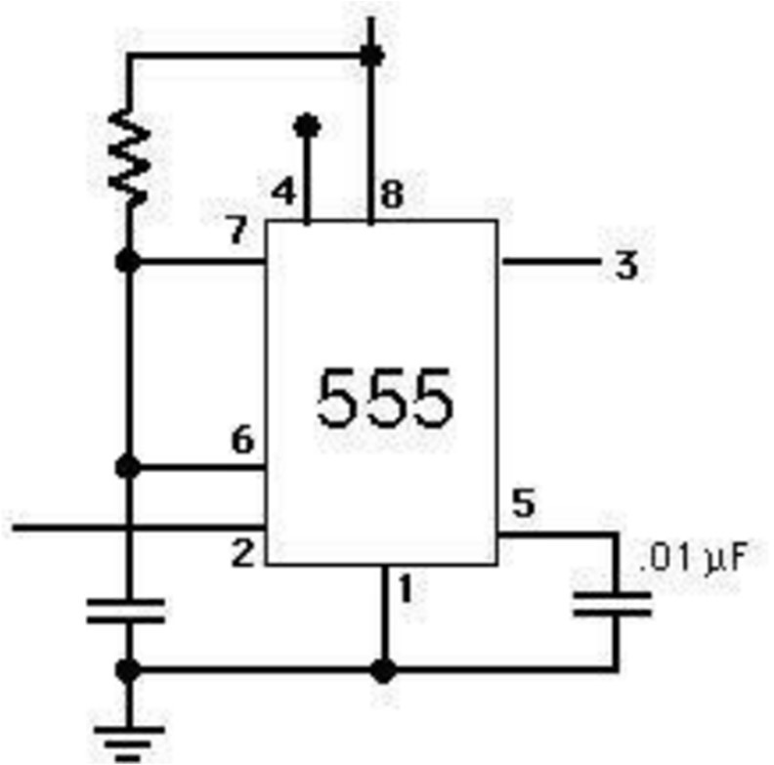

Figure 3:555 timers connected as a one-shot multivibrator

# Apparatus:

* Resistors 22k
* Resistor 10k
* Capacitor 0.01uF
* Capacitor 100uF
* 555 Timer IC

# Precautions:

We never turned on the DC source before the circuit is placed correctly and checked carefully. We checked for short circuits in the circuit.

# Experimental Procedure:

# For Astable mode pin-2 was a shorted to pin-6 and the output pin-3 was connected to a led. Output pulse was then observed.

# For Monostable mode a triggering pulse was applied to pin-2 as shown in Figure 5. The output was monitored at pin 3.

* We constructed the astable multivibrator and monostable multivibrator by the help of the following figures.

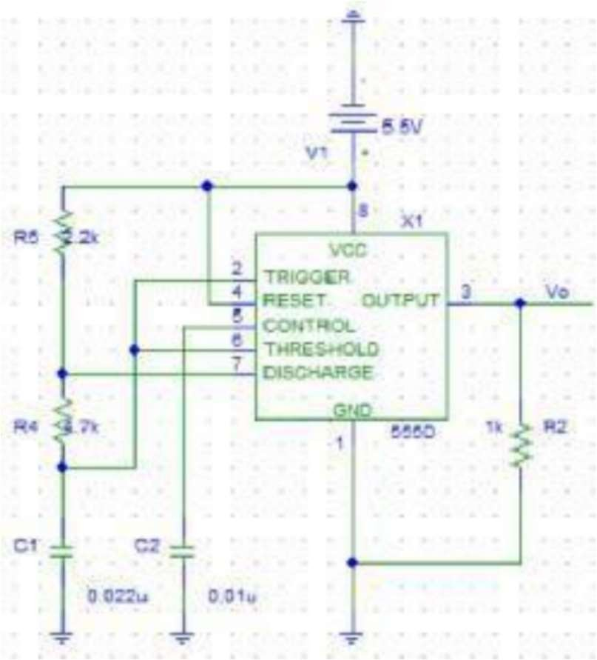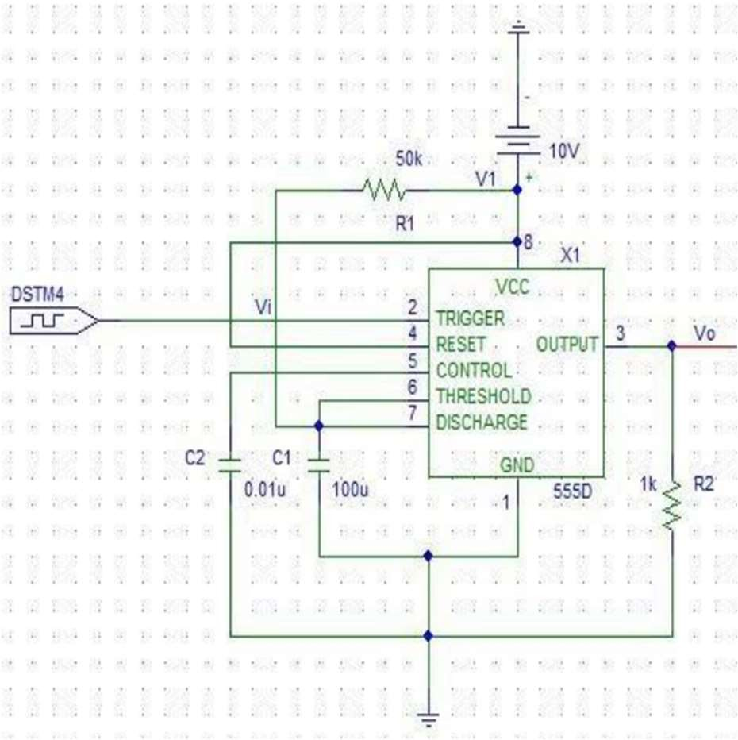

Figure 4:Experimental setup for Astable multivibrator.

Figure 5:Experimental setup for Monostable multivibrator.

# Simulation and Measurement:

**555 timers (Astable mode):**

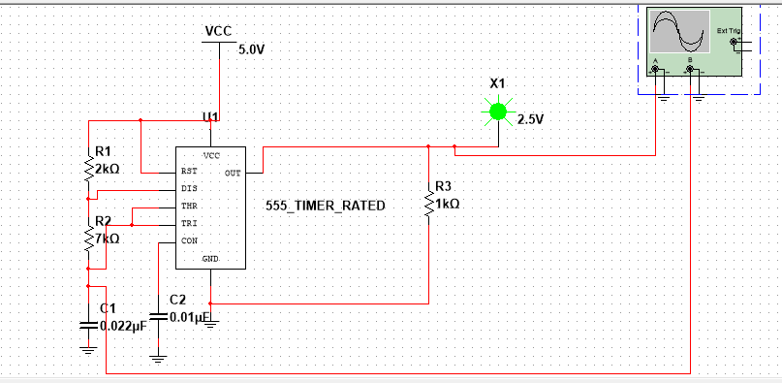

Figure-6: Experimental setup for astable multivibrator.

# 555 timers (Monostable mode):

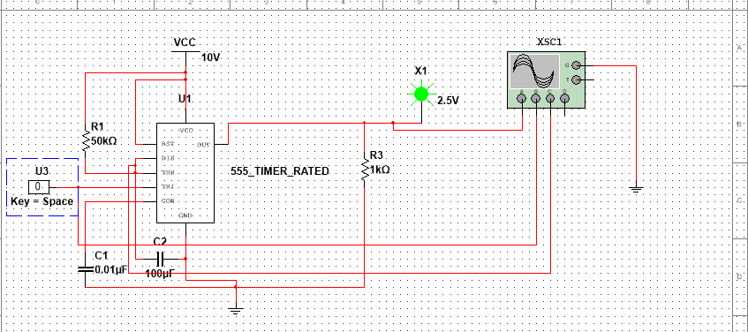

Figure-7: Experimental setup of the monostable multivibrator.

# Discussion and Conclusion:

In this experiment, we explored timer IC called 555 timer with its two working modes: Astable mode and Monostable Mode. Through the experiment, we became familiar with how it works in those two modes. Moreover, we successfully made the circuit diagram depending on the two modes utilizing the high and low pulse, we extracted our desired output. We used Multisim software for the simulation part. When doing simulation, we faced some errors and later fixed them. This experiment deepened our understanding of 555 timer IC and its behavior under different conditions-pulses, empowering us to design and analyze specific applications based on similar timer ICs and input characteristics.

**References:**

1. Boylestad, Robert L., and Louis Nashelsky. *Electronic Devices And Circuit Theory*, 2006, Pearson Prentice Hall.
2. Thomas L. Floyd, *Digital Fundamentals*, 9th Edition, 2006, Prentice Hall.